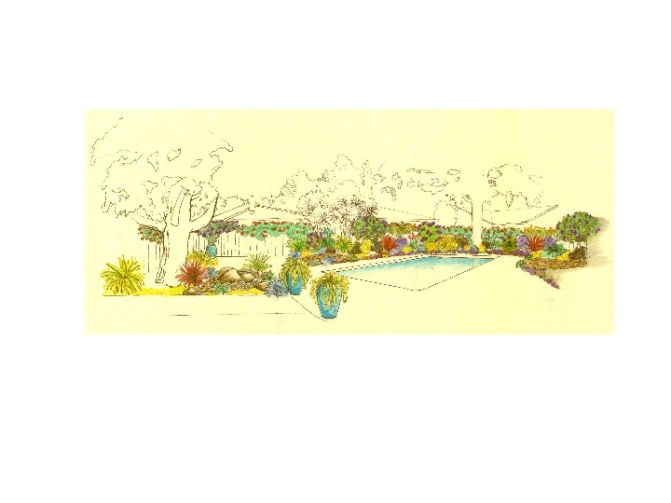
Stonehedge Swim Club
RULES AND REGULATIONS
Of the Stonehedge Swim Club, Inc.
A non-profit corporation owned by select residents of the Stonehedge Community
(A California Non-Profit Corporation)
Membership in the Stonehedge Swim Club requires adherence to these Rules and Regulations. All household members, including children and guests, must be cognizant and respectful of these Rules. The Stonehedge Swim Club Rules and Regulations apply at all times without exception.

Hours and Eligibility
- The pool is open for use from April 1 through October 31, from 7:00 AM to 10:00 PM.
- The pool and its facilities shall be open for use to all adult members, unaccompanied minors aged 14 and older, and children under the age of 14 when accompanied by an adult members.
- A pool member must accompany guests. Members are responsible for guest conduct.
- Members shall invite no more than three (3) guests at any time, unless they are hosting an SSC Board approved party. See Addendum 1 to Rules and Regulations, Parties and Events.
- Teenage members between the ages of 14 and 18 may have a maximum of two (2) guests at any time, unless accompanied by an adult. Minors under the age of 18 years may at no time be within the pool grounds alone, there must always be at least two people present.

Heath Rules
- All persons using the pool are required to shower prior to entering pool and after use of suntan oil.
- All swimmers must wear bathing suits, trunks or swim diapers. No jeans or cut-offs.
- Toilet and restroom facilities are available while pool is open. Please remind small children to use the toilet, flush and wash hands. Urination anywhere other than a toilet is prohibited.
- Showers are for rinsing off before and after swimming. Shampooing hair is allowed, but no alteration to shower faucet or nozzle is allowed.
- Restrooms and showers are never to be used for recreational activity. No exceptions.

Safety Rules
- The lifeguard, member and/or responsible adult are required to enforce all of the rules covering conduct and safety in the pool and may clear the pool at any time.
- Food and beverages are not allowed in the pool at any time. Food, soft drinks, beer and wine are allowed in the picnic or grass area of the pool. No member or guest under the age of 21 may consume alcoholic beverages at any time.
- No running within the pool grounds. Please remind children to walk from one end of the pool to the other.
- No pushing or throwing person into the pool at any time.
- No disorderly conduct, horseplay, or “chicken” games are allowed in the pool. No dunking or endurance contests ever, no exceptions.
- Floatation devices used to assist young children in the pool are allowed at any time. All other rafts, toys and flotation devices may be used at the discretion of the responsible adult if the pool is not crowded. Please be respectful of others in the pool and discontinue use if small children or lap swimmers are present. No water may be splashed or squirted outside of the pool.
- Pool and corporation equipment are to be handled only by pool personnel.
- No dogs or pets of any kind are permitted within the pool enclosure.
- Children under 14 years of age within the pool enclosure MUST BE ACCOMPANIED BY AN ADULT AT ALL TIMES, no exceptions.
- No one under the age of 18 is allowed in the pool after dark unless accompanied by an adult.
- Trash receptacles are available for usual and ordinary refuse. Excessive amounts of trash, heavy objects, and heavily soiled items should be taken home. The pool does not have trash service. As a general rule, if you bring it in, please bring it out.

Enforcement of the Rules
- Any flagrant violations of any of the rules and regulations will be cause for suspension or cancellation of membership privileges. Such action will be taken upon unanimous vote of the Board of Directors.
- The last adult member leaving the pool area is required to clear the pool area of all swimmers under the age of 14.
- Anyone leaving the pool area must make sure the gate is closed and locked. Do not leave the gate ajar under any circumstances, or inhibit gate closure in any way. Any member noticing that the gate will not self close must report this to a pool officer immediately.
- Board members may receive written complaints regarding infractions of the rules and may put any member on a probationary status at any time for flagrant violations.
- Please leave the pool in the same or better condition as when you arrived. Pick up trash, straighten furniture and make sure all is safe and orderly. This pool belongs to all of us, and we need to respect that others want to enjoy the pool facilities without having to clean up after members and guests. The Stonehedge Swim Club is a family friendly facility. Please be respectful of language and behavior.

In an Emergency
- Call 911
- Relay address: Stonehedge Swim Club: 905 Cherrystone Dr. on the northeast corner of Cherrystone and Cherry Blossom.
- Call or find an Officer of the Pool:
Morgan Friberg– (415) 889-0767
Steven Hood – (408) 386-2793
Bill Gallmeister – (408) 781-0460
Shari Harper – (408) 858-2214

Definitions
Adult Member: Any person 18 or over; Teenage Member: Ages 14-17; Children: Ages 13 and under Guest: Any non-member person who is visiting the pool in attendance with a host member.

