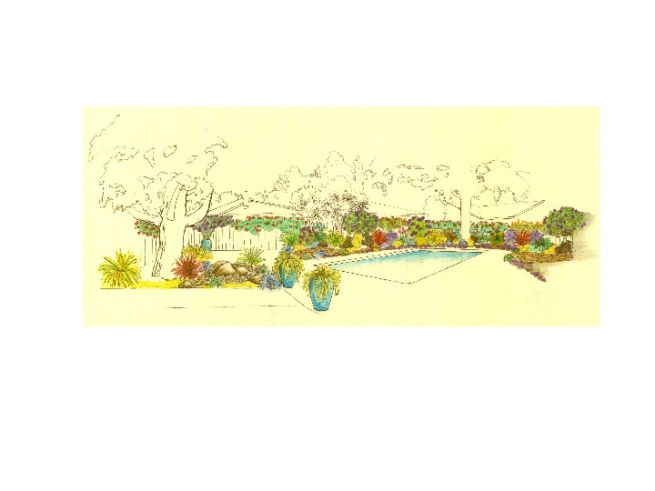
Stonehedge Swim Club
SAFETY RULES AND REGULATIONS
The Stonehedge Swim Club Rules and Regulations apply at all times without exception.
A non-profit corporation owned by select residents of the Blossom Manor Community

- The lifeguard, member and/or responsible adult are required to enforce all of the rules covering conduct and safety in the pool and may clear the pool at any time.
- Food and beverages are not allowed in the pool at any time. Food, soft drinks, beer and wine are allowed in the picnic or grass area of the pool. No member or guest under the age of 21 may consume alcoholic beverages at any time.
- No running within the pool grounds. Please remind children to walk from one end of the pool to the other.
- No pushing or throwing person into the pool at any time.
- No disorderly conduct, horseplay, or “chicken” games are allowed in the pool. No dunking or endurance contests ever, no exceptions.
- Floatation devices used to assist young children in the pool are allowed at any time. All other rafts, toys and flotation devices may be used at the discretion of the responsible adult if the pool is not crowded. Please be respectful of others in the pool and discontinue use if small children or lap swimmers are present. No water may be splashed or squirted outside of the pool.
- Pool and corporation equipment are to be handled only by pool personnel.
- Children under 14 years of age within the pool enclosure MUST BE ACCOMPANIED BY AN ADULT AT ALL TIMES, no exceptions.
- No one under the age of 18 is allowed in the pool after dark unless accompanied by an adult.

